A

Project on

ATM MANAGEMENT SYSTEM SOFTWARE

Submitted

In

Partial Fulfillment of the Requirement for the Award of the Degree of

Bachelor of Computer Application

(BCA- III)

For

Session:- 2025-26


Submitted To: Submitted by:

MR. PELE SENGUPTA MANISH SAHU

(ASST.PROFESSOR) ROLL NO- ……

At

CENTRAL COLLEGE OF IT FAFADIH

AFFIlLIATED TO

PT. RAVISHANKAR SHUKLA UNIVERSITY, RAIPUR (C.G.)

Central College of IT
PT. RAVISHANKAR SHUKLA UNIVERSITY, RAIPUR (C.G.)

CERTIFICATE OF APPROVAL

This is to certify that the Project work entitled "ATM Management SYSTEM PROJECT " is carried out by MANISH KUMAR SAHU a student of BCA-III year at CENTRAL COLLEGE OF IT is here by approved as a credible work in the discipline of Computer Science & Information Technology for the award of degree of BACHELOR OF COMPUTER APPLICATIONS during the year 2025-26 from PT. RAVISHANKAR SHUKLA UNIVERSITY, RAIPUR (C.G.).

PRINCIPAL
MR. JOGRAJ SINGH
CENTRAL COLLEGE OF IT,
FAFADIH, RAIPUR (C.G.)

CERTIFICATE OF APPROVAL

This is to certify that the Project work entitled "ATM Management System Project" is carried out by MANISH KUMAR SAHU a student of BCA-III year at CENTRAL COLLEGE OF IT is here by approved as a credible work in the discipline of Computer Science & Information Technology for the award of degree of BACHELOR OF COMPUTER APPLICATIONS during the year 2025-26 from PT. RAVISHANKAR SHUKLA UNIVERSITY, RAPUR (C.G.).

COORDINATOR
MRS. SEEMA BHATT
CENTRAL COLLEGE OF IT,
FAFADIH, RAIPUR (C.G.)

CERTIFICATE

This is to certify that the Project work entitled “ATM MANAGEMENT SYSTEM" submitted to the CENTRAL COLLEGE OF IT by Manish Kumar Sahu, Roll No .........., in partial fulfillment for the requirements relating to nature and standard of the award of Bachelor of Computer Application- III Year degree by,
Pt. Ravishankar Shukla University, Raipur (C.G.)
for the academic year 2025-2026.
This project work has been carried out under my guidance.

Guided By

MR. PELE SENGUPTA
(Asst. Professor)
Central College of IT
FAFADIH, RAIPUR (CG)

CERTIFICATE OF EVALUATION

This is to certify that the project work entitled "ATM MANAGEMENT SYSTEM" is carried out by Manish Kumar Sahu, a student of BCA III YEAR at CENTRAL COLLEGE OF IT, after proper evaluation and examination, is hereby approved as a credible work in the discipline of Computer Science & Information Technology and is done in a satisfactory manner for its acceptance as a requisite for the award of degree of BACHELOR OF COMPUTER APPLICATION- III Year during the year 2025-2026 from Pt. Ravishankar Shukla University, Raipur(C.G.).

Internal Examiner External Examiner

DECLARATION

This to certify that the project report entitled "ATM MANAGEMENT SYSTEM" which is submitted by me in the partial fulfillment for the award of the degree BACHELOR OF COMPUTER APPLICATION, CENTRAL COLLEGE OF IT, comprises the original work carried out by me.

Place: MANISH KUMAR SAHU

Date: ROLL NO :-……………..

ACKNOWLEDGEMENT

Success is the manifestation of diligence, perseverance, inspiration, motivation and innovation. The completion of any interdisciplinary project depends on co-operation, co-ordination and combined efforts of several sources of knowledge, energy and time. Hence, I approach this matter of acknowledgement through these lines trying my best to give full credit wherever it is due,
I take immense pleasure in thanking COORDINATOR of Computer Department for having permitted me to carry out this project work
I wish to express my deep sense of gratitude to my Guide, Mr. Pele Sengupta (Asst. Professor), who had been a source of inspiration and for his timely guidance and useful suggestions, which helped me in completing the project work, in time.

Words are inadequate in offering my thanks to the teachers, Project Trainees and Project Assistants, for their encouragement and cooperation in carrying out the project work.

Finally, yet importantly, I would like to express my heartfelt thanks to my beloved parents for their blessings, my friends/classmates for their help and wishes for the successful completion of this project and as always, nothing in my life would be possible without God, Thank You!

MANISH KUMAR SAHU

Table of Content
S. No. | Content | Page No.
1. | INTRODUCTION | 1
2. | SYSTEM OVERVIEW | 16
3. | SYSTEM ANALYSIS | 18
4. | SYSTEM DESIGN | 29
5. | STRUCTURE DESIGN | 36
6. | MODULE DESCRIPTION | 39
7. | DESGIN STRATEGY | 40
8. | DFD (DATA FLOW DIAGRAM) | 42
9. | ER-DIAGRAM | 44
10. | PROGRAM SPECIFICATION | 47
11. | IMPLEMENTATION | 51
12. | TESTING | 62
13. | APPLICATION OF PROJECT | 65
14. | FUTURE SCOPE | 67
15. | CONCLUSION | 69
16. | REFERENCE | 70

INTRODUCTION

The ATM Management System is a software application designed to perform basic banking operations such as cash withdrawal, balance enquiry, fund transfer and PIN change. It provides users with a simple and secure way to access their account information.
This system reduces manual work and improves accuracy in banking activities. It helps users to complete transactions quickly while maintaining proper records. The project also gives a clear idea of how real-life ATM systems work in a computerized environment.

ABOUT PROJECT:-

The ATM Management System is developed to automate common banking operations in an easy and efficient manner. The project allows users to perform transactions like balance enquiry, cash withdrawal, fund transfer and PIN change.
This system ensures faster processing, better accuracy and secure handling of user data. It is designed to simulate the working of a real ATM and helps in understanding practical banking system operations.
Objectives of the Project :

- To develop a simple and user-friendly ATM Management System

- To provide secure banking operations like balance enquiry and fund transfer

- To reduce manual work and save time

- To maintain accurate records of customer transactions

- To improve efficiency in banking services

System Features :
- User friendly interface
- Secure login system
- Balance inquiry facility
- Cash withdrawal feature
- Fund transfer option
- PIN change facility
- Fast and accurate transactions

Project Overview :

The ATM Management System is a desktop-based software application developed to simulate the working of an Automated Teller Machine (ATM).
This project is designed to provide users with basic banking services such as balance inquiry, cash withdrawal, fund transfer, PIN change, and customer support services in a secure and user-friendly environment.
The main purpose of this system is to reduce manual banking operations and provide fast, reliable, and accurate services to users.
The system stores customer data such as account number, PIN, balance, and transaction details in a database and retrieves the information whenever required.
Each user can securely access their account and perform transactions without the need to visit a bank branch.
The ATM Management System ensures proper validation at every step to avoid incorrect transactions and unauthorized access.
It checks account details, verifies balance availability, and updates records automatically after every transaction.
This helps in maintaining data accuracy and consistency.
The application is easy to use and designed in such a way that even non-technical users can operate it comfortably.
It provides a simple graphical interface that guides the user through each operation step by step.
Overall, this project demonstrates how banking operations can be computerized using software, making financial services more efficient, secure, and accessible.
It is suitable as a major academic project and helps in understanding real-world ATM functionality.
Frontend (Visual Basic 2026)

- The frontend of the ATM Management System is developed using Visual Basic 2026.
- It provides a graphical user interface for users to interact with the system.
- The frontend includes forms such as Login Form, Main Menu, Balance Inquiry, Cash Withdrawal, Fund Transfer, PIN Change, and Services.
- Users enter data using text boxes and select options using buttons.
- Labels are used to display account information and system messages.
- Message boxes are used to show alerts, errors, and successful transaction messages.
- Visual Basic 2026 helps in creating a simple, attractive, and user-friendly interface.

Backend (MS Access 2007)

- The backend of the ATM Management System is developed using MS Access 2007.
- It is used to store and manage all the database records of the system.
- The database contains tables for account details, PIN numbers, balance, and transactions.
- MS Access 2007 stores user data securely and efficiently.
It helps in retrieving and updating account information during transactions.
- Backend logic ensures correct balance calculation and data consistency.
- MS Access 2007 provides reliable data storage for smooth system performance.

Programming Process :

- The development of the ATM Management System follows a systematic programming process to ensure smooth and reliable performance.
- Requirement Analysis:
In this phase, all system requirements are identified such as user login, balance enquiry, cash withdrawal, PIN change, fund transfer, and customer services. User needs and system objectives are clearly analyzed before development begins.

- System Design:
The complete structure of the system is designed in this phase. User-friendly forms are designed using labels, text boxes, and buttons. The database structure and data flow are planned using MS Access 2007.

- Development:
In the development phase, the actual coding of the system is done. The frontend is developed using Visual Basic 2026, while MS Access 2007 is used as the backend database. All modules are integrated properly.

- Testing:
The system is tested to ensure accuracy and reliability. Each function is checked to remove errors and ensure correct output.

- Deployment:
After successful testing, the software is deployed for use. The system becomes ready for real-time ATM operations.

- Maintenance:
Maintenance is performed regularly to fix issues, improve performance, and update features for future requirements.

Problem Definition :

- Manual ATM systems are time-consuming and may cause errors in transactions.
- Maintaining customer account and balance records manually is difficult.
- Existing systems lack proper security for PIN and user authentication.
- Customers do not get quick access to balance enquiry and fund transfer services.
- Transaction details are not stored and managed efficiently.
There is a need for a fast, secure, and user-friendly ATM management software.

Existing System :

- The existing ATM system mostly depends on manual or semi-automatic processes.
- User authentication and PIN verification are not fully secure.
- Balance enquiry and fund transfer processes take more time.
- Data is not properly stored and managed in a centralized database.
- There are higher chances of human error during transactions.
- The system is not user-friendly and difficult to maintain.
Limitations of Existing System :

Existing systems are time-consuming and less efficient.

Security level is low, increasing the risk of fraud and data misuse.

Manual work increases the chances of errors in transactions.

Data backup and recovery facilities are not properly available.

System performance becomes slow when the number of users increases.

Maintenance and updating of the system is difficult and costly.
Every manager faces a lot of minor and major problems LIKE :
- Handling large amounts of data manually.
- Maintaining accuracy in daily transactions.
- Ensuring proper security of user information.
- Managing time efficiently for multiple operations.
- Monitoring account activities and balances.
* Reducing operational errors and system failures.
Proposed System

The proposed system is an ATM Management System software designed to overcome the limitations of the existing manual and semi-manual systems. This system automates all major ATM operations and provides a secure, fast, and user-friendly environment.

The system allows users to perform essential banking operations such as cash withdrawal, balance inquiry, fund transfer, PIN change, and customer services through a single integrated platform. It ensures accurate data handling, reduces human errors, and improves transaction speed.

The proposed system enhances data security, maintains proper transaction records, and supports easy monitoring of account details. It also reduces workload on bank staff and improves overall efficiency and reliability of ATM operations.

SYSTEM
OVERVIEW

System overview :

The ATM Management System is a computerized application developed to perform essential banking operations in a simple, secure, and user-friendly manner. This system is designed to automate ATM-related activities and provide customers with quick access to their bank accounts without visiting a bank branch.
The system allows users to perform various operations such as cash withdrawal, balance inquiry, fund transfer, PIN change, and viewing service information. Each transaction is processed securely by validating account details and maintaining accurate records in the database. This helps in reducing manual work, saving time, and minimizing errors.
The ATM Management System improves efficiency by ensuring fast transaction processing and better data management. It provides a smooth interface where users can easily navigate through different options. The system also maintains confidentiality of user data and supports reliable transaction handling.
Overall, this project demonstrates how banking operations can be managed digitally with improved speed, accuracy, and security, making it useful for both users and administrators.

SYSTEM
ANALYSIS

System Analysis :

System analysis is the process of examining the system requirements and understanding how the ATM Management System will work. It helps in identifying user needs, system functions, and data processing methods.
The ATM Management System is designed to provide users with basic banking services such as balance inquiry, cash withdrawal, fund transfer, PIN change, and service information. The system ensures that only authorized users can access their accounts through secure login credentials.
The system interacts with the backend database to fetch and update customer details, account balance, and transaction records. Each transaction is validated to maintain accuracy and security. Error handling is included to manage invalid inputs or insufficient balance situations.
Through proper system analysis, the ATM Management System becomes reliable, efficient, and user-friendly, making banking operations faster and more convenient for users.

SYSTEM
DESIGN

System Design :

The system design of the ATM Management System explains how the system is structured and how different modules work together. The system is designed in a simple and user-friendly manner so that users can perform banking operations easily.
The application follows a modular approach where each function such as login, balance inquiry, cash withdrawal, fund transfer, PIN change, and service information works as an independent module. This makes the system easy to manage and maintain.

The frontend of the system is developed using Visual Basic 2026, which provides an interactive graphical user interface using forms, buttons, labels, and text boxes. Proper validations are used to ensure correct input from users.

The backend is designed using MS Access 2007, which stores all customer and account-related information such as account number, PIN, balance, and transaction details. The system securely connects with the database to fetch and update records.
Security is ensured through PIN verification and controlled access to data. Error handling is implemented to display appropriate messages for invalid inputs or failed operations. Overall, the system design focuses on simplicity, security, and efficient performance.

STRUCTURE
DESIGN

Structure Design :

The structure design of the ATM Management System defines the overall framework of the system and the relationship between its components. The system is structured in a hierarchical manner to ensure smooth flow of operations and easy control.
The application consists of multiple forms such as Login Form, Main Menu Form, Balance Inquiry Form, Withdrawal Form, Fund Transfer Form, PIN Change Form, and Services Form. Each form is connected through buttons and events, allowing proper navigation within the system.
The system follows a front-end and back-end architecture. The front-end handles user interaction through Visual Basic forms, while the back-end manages data storage using MS Access database. Communication between the forms and database is done using secure database connections.
Each module performs a specific task and shares data only when required. This modular structure improves system performance, reduces complexity, and makes future enhancements easier.
Overall, the structured design ensures better organization, data consistency, and reliable operation of the ATM Management System.

MODULE
DESCRIPTION

Module Description

The ATM Management System is divided into several modules to perform different banking operations efficiently. Each module is designed to handle a specific function of the system.
1. Login Module
This module is used to authenticate the user by verifying the account number and PIN. It ensures secure access to the system and prevents unauthorized usage.
2. Main Menu Module
After successful login, this module displays all available services such as Balance Inquiry, Cash Withdrawal, Fund Transfer, PIN Change, and Services. It acts as a central control panel for the system.
3. Balance Inquiry Module
This module allows the user to check the current account balance. It retrieves balance details from the database and displays them to the user.
4. Cash Withdrawal Module
This module enables users to withdraw money from their account. It checks available balance, validates the entered amount, and updates the balance after successful withdrawal.
5. Fund Transfer Module
This module allows users to transfer funds from one account to another. It verifies both accounts, checks sufficient balance, and updates account balances securely.
6. PIN Change Module
This module allows users to change their ATM PIN. It verifies the old PIN and updates the new PIN securely in the database.
7. Services Module
This module provides ATM-related information such as helpline number, email support, date, and time for user assistance.

DESIGN
STRATEGY

Design Strategy

The system is designed using a modular approach for better organization.

Each module performs a specific function independently.

User-friendly interface is created for easy navigation.

Frontend is developed using Visual Basic 2026.

Backend database is managed using MS Access 2007.

Secure login and PIN verification are implemented.

Proper input validation is used to avoid errors.

Database is updated after every successful transaction.

Error handling ensures smooth system operation.

The design supports easy maintenance and future enhancements.

DATA
FLOW
DIAGRAM
DFD (Data Flow Diagram) LEVEL 0
User enters account number and PIN into the ATM Management System.
The system verifies user details from the database.
User selects ATM services such as balance inquiry, withdrawal, fund transfer, or PIN change.
The system processes the request and interacts with the database.
Final result or message is displayed to the user.

DFD Level 1
Login Process
User provides account number and PIN.
System validates credentials using database records.
Balance Inquiry Process
System fetches account balance from the database.
Balance is displayed to the user.
Cash Withdrawal Process
User enters withdrawal amount.
System checks balance and updates it after withdrawal.
Fund Transfer Process
User enters receiver account and amount.
System verifies both accounts and updates balances.
PIN Change Process
User enters old and new PIN.
System updates PIN in the database.
Services Process
System displays helpline, email, date, and time information.
DFD LEVEL 0 (CONTEXT DIAGRAM)

┌────────────┐
│ User │
└─────┬──────┘
│
Account No, PIN,
Transaction Request
│
▼
┌──────────────────────┐
│ ATM Management System│
└─────┬────────────────┘
│
Result / Balance /
Transaction Status
│
▼
┌────────────┐
│ User │
└────────────┘
│
▼
┌────────────────┐
│ Database │
│ (MS Access) │
└────────────────┘

DFD LEVEL 1 (DETAILED DIAGRAM)

┌──────────┐
│ User │
└────┬─────┘
│ Account No, PIN
▼
┌────────────────┐
│ Login Process │
└────┬───────────┘
│ Valid User
▼
┌────────────────────────┐
│ ATM Main Menu │
└────┬──────┬─────┬─────┘
│ │ │
▼ ▼ ▼
┌────────┐ ┌──────────┐ ┌──────────┐
│Balance │ │Withdraw │ │Transfer │
│Inquiry │ │Process │ │Process │
└──┬─────┘ └──┬───────┘ └──┬───────┘
│ │ │

└───────────┴──────────────┘
▼
┌────────────────┐
│ Database │
│ (MS Access) │
└────────────────┘
│
▼
Result / Message
│
▼
┌─────┐
│User │
└─────┘

ER-DIAGRAM

ER-Diagram Explanation

Customer Entity stores customer details such as name, address, and phone number.
Account Entity stores account number, balance, and PIN. Each customer has one account.
Transaction Entity records all transactions such as withdrawal, fund transfer, and balance inquiry. One account can have many transactions.
ATM Entity represents the ATM machine where transactions are performed.

Relationships :

One Customer has one Account
One Account can have many Transactions
Many Transactions are performed through one ATM

┌──────────────┐ ┌──────────────┐
│ CUSTOMER │ │ ACCOUNT │
├──────────────┤ ├──────────────┤
│ Cust_ID (PK) │◄──────► │ Acc_No (PK) │
│ Cust_Name │ 1 : 1 │ Balance │
│ Address │ │ PIN │
│ Phone_No │ │ Cust_ID (FK) │
└──────────────┘ └──────────────┘
│
│ 1 : Many
▼
┌──────────────────┐
│ TRANSACTION │
├──────────────────┤
│ Trans_ID (PK) │
│ Acc_No (FK) │
│ Trans_Type │
│ Amount │
│ Date_Time │
└──────────────────┘
│
│ Many : 1
▼
┌──────────────────┐
│ ATM │
├──────────────────┤
│ ATM_ID (PK) │
│ Location │
│ Status │
└──────────────────┘

PROGRAM
SPECIFICATION

PROGRAM SPECIFICATION

The ATM Management System is designed to provide secure, fast, and reliable banking services to customers through an automated platform. This system allows users to perform essential banking operations such as balance inquiry, cash withdrawal, cash deposit, and transaction viewing without manual bank assistance.

The system begins with user authentication, where the customer enters the account number and PIN. After successful verification, the system displays a menu of available services. Each selected operation is processed according to predefined business rules to ensure accuracy and security.

The system maintains proper validation checks such as sufficient balance verification during withdrawal, correct account details, and transaction limits. All transactions are recorded with date and time to maintain transparency and data consistency.

The ATM Management System is developed using a modular approach, where each function is handled by a separate program module. This improves system performance, simplifies debugging, and allows easy future enhancements. The system also ensures data integrity by updating account balance automatically after every transaction.

Overall, the system reduces manual work, minimizes human errors, and improves customer convenience by providing 24×7 banking services.

---

Functional Specifications

- User login using account number and PIN
- Balance inquiry facility
- Cash withdrawal with balance validation
- Cash deposit functionality
- Transaction history display
- Secure logout after transaction

---

Non-Functional Specifications

- User-friendly interface
- Fast response time
- Secure data handling
- Reliable transaction processing
- Easy maintenance and scalability

---

Input Specifications

- Account Number
- PIN
- Transaction Type
- Amount

---

Output Specifications

- Account Balance
- Transaction Receipt
- Transaction Status Message

---

Error Handling

- Invalid account number or PIN message
- Insufficient balance warning
- Transaction failure notification

---

This program specification ensures that the ATM Management System works efficiently, securely, and accurately to meet user requirements.

IMPLEMENTATION

IMPLEMENTATION

The ATM Management System is implemented using Visual Basic 2026 as the front-end and MS Access 2007 as the back-end database. The system follows a structured and modular programming approach to ensure simplicity, reliability, and ease of maintenance.

The front-end is developed in Visual Basic 2026, which provides a user-friendly graphical interface. Forms are designed for login, transaction selection, cash withdrawal, cash deposit, balance inquiry, and transaction history. Proper input validation is applied to avoid incorrect data entry such as invalid account number, PIN, or transaction amount.

The back-end database is created using MS Access 2007. It contains tables such as Customer, Account, Transaction, and ATM. These tables are connected using primary keys and foreign keys to maintain data integrity and avoid redundancy. Database connectivity is established using OLE DB for smooth data communication between the application and database.

During implementation, each module is coded separately. The login module verifies account number and PIN. The withdrawal module checks available balance before processing the transaction. The deposit module updates the account balance accordingly. Every transaction is stored in the transaction table with date and time for future reference.

Exception handling techniques are implemented to manage runtime errors such as invalid inputs, insufficient balance, or database connection issues. After completing the transaction, the system displays a confirmation message and safely logs out the user.

Overall, the implementation ensures secure transaction processing, accurate data management, and efficient system performance.
---
Tools and Technologies Used

- Frontend: Visual Basic 2026
- Backend: MS Access 2007
- Database Connectivity: OLE DB
- Platform: Windows Operating System

---

The implementation phase successfully converts the system design into a fully functional ATM Management System.
SPLASH SCREEN
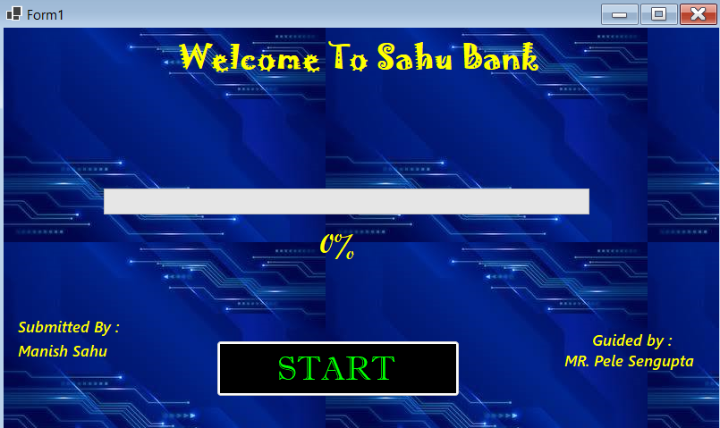

ENTER PIN FORM

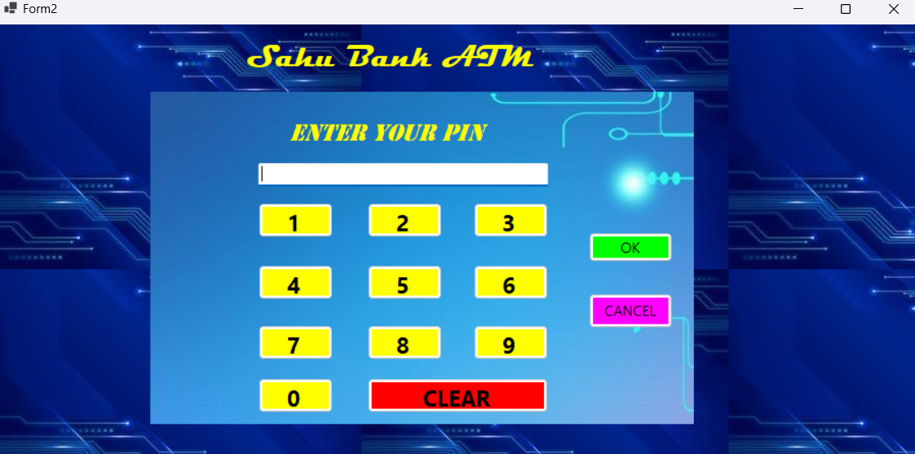
HOME PAGE
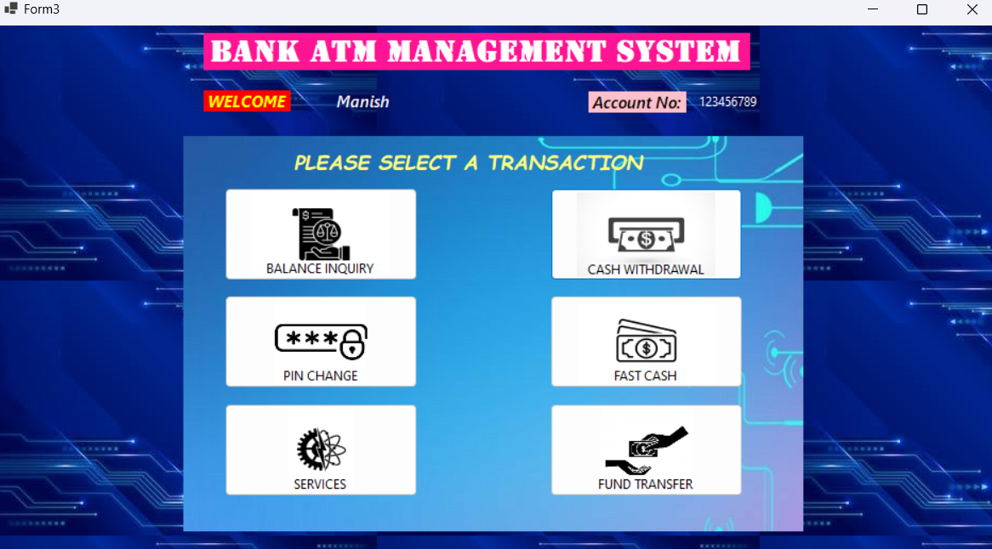

WITHDRAWAL FORM
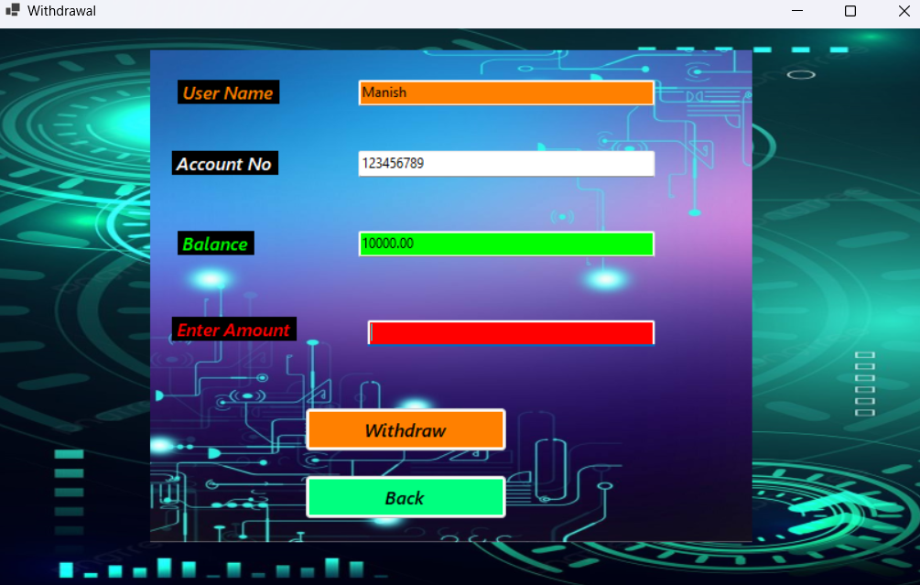
FAST CASH FORM
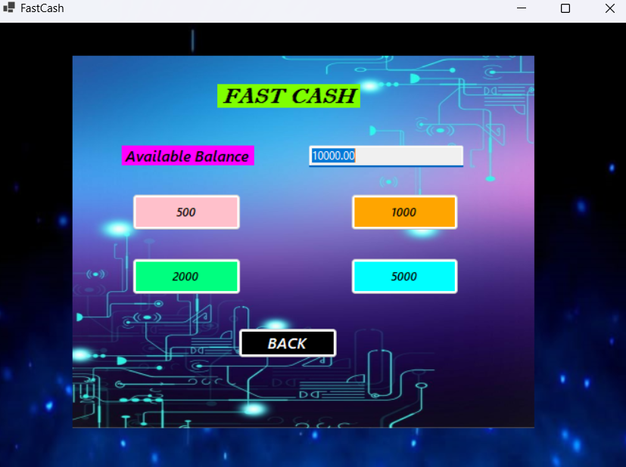

FUND TRANSFER FORM

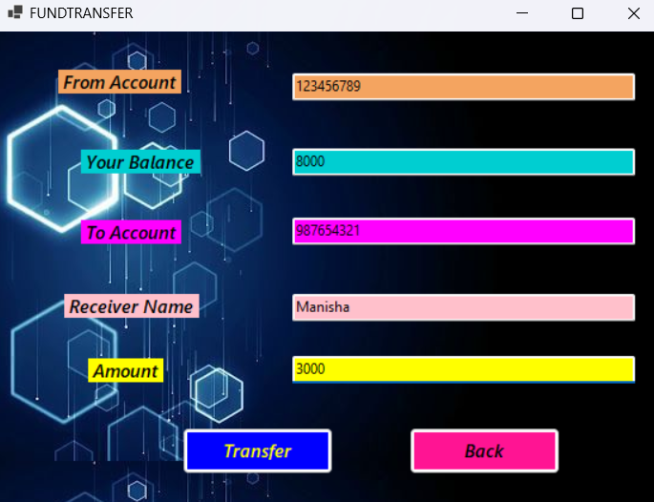

BALANCE INQUIRY FORM

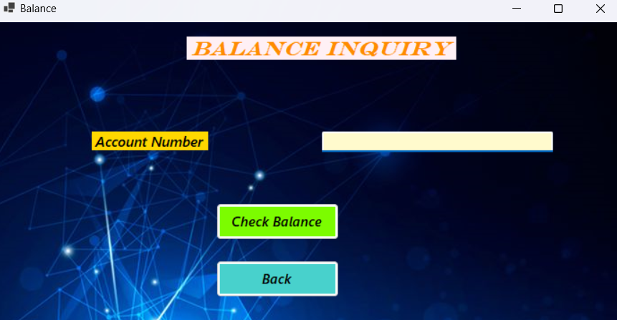

PIN CHANGE FORM
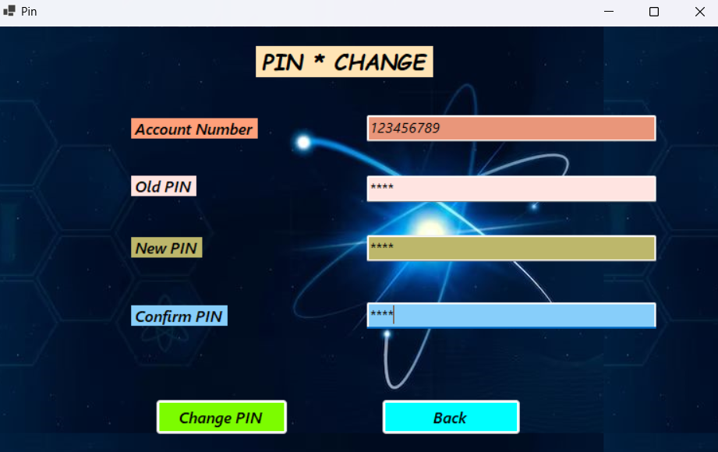
SERVICES FORM

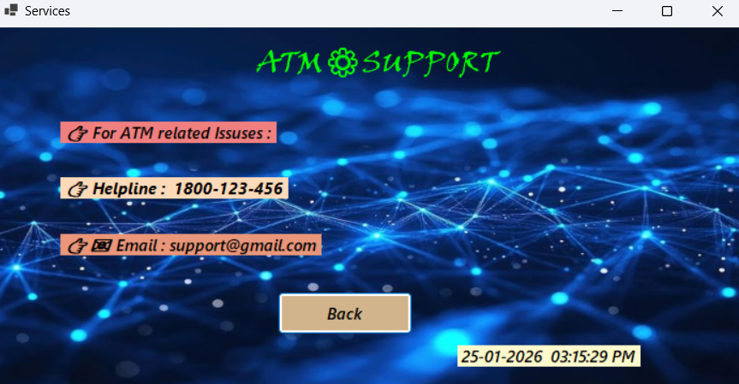

DATABASE DESIGN

DATABASE TABLE DESIGN

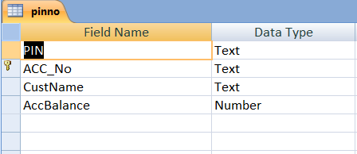

TABLE DATA VIEW

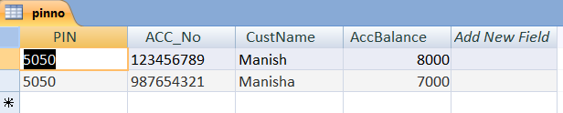

TESTING

Testing

Testing is an important phase of the ATM Management System which ensures that the system works correctly and securely. All modules of the system were tested to identify and remove errors before final deployment. The testing process helps in verifying that the system meets the required functionality and provides accurate results.

Different types of tests were performed such as login testing, balance inquiry testing, cash withdrawal testing, PIN change testing, and database validation testing. Each input was checked to ensure proper validation and error handling. Incorrect inputs were also tested to confirm that the system displays appropriate error messages.

The system was tested using real-time data stored in the database to verify data accuracy, security, and performance. After successful testing, the system was found to be reliable, user-friendly, and free from major errors.

APPLICATION
OF
PROJECT
Application of Project

The ATM Management System is mainly used to perform banking operations in an easy and secure way. This system allows customers to access their account by using an ATM card and PIN for various services such as cash withdrawal, balance inquiry, PIN change, and fund transfer.
The project can be used in banks to reduce manual work and improve efficiency. It helps in maintaining accurate customer records, transaction details, and account balance in the database. The system also ensures security by validating user credentials before performing any transaction.
This project is useful for educational purposes as well as for understanding real-time banking systems. It provides a basic model of how ATM software works in real banking environments.

FUTURE
SCOPE

Future Scope

The ATM Management System can be enhanced in the future by adding several advanced and modern features. Biometric authentication such as fingerprint, face recognition, or iris scan can be implemented to increase security and reduce fraud. One-time password (OTP) based verification can also be added for an extra security layer.
The system can be upgraded to use a centralized online database so that transactions can be performed from any ATM branch in real time. Integration with mobile banking and internet banking systems can allow users to receive SMS or email alerts for every transaction.
Additional features such as mini statement printing, QR code-based transactions, cardless cash withdrawal, and multi-language support can be introduced to improve user convenience. The system can also be converted into a web-based or mobile application for wider accessibility.
In the future, advanced reporting, data analytics, and AI-based fraud detection can be added to monitor suspicious activities. Regular software updates and cloud-based deployment can further improve performance, scalability, and reliability.

Conclusion

The ATM Management System has been successfully designed and developed to automate essential banking operations in a secure and efficient manner. The system provides key services such as balance inquiry, cash withdrawal, PIN change, and transaction management, which reduces manual effort and improves operational accuracy.
During the development of this project, several real-world software engineering challenges were addressed. These include ensuring data security for sensitive information like account details and PINs, maintaining data accuracy during financial transactions, handling runtime errors, and managing smooth communication between the application and the database. Performance reliability and user-friendly interface design were also important considerations to make the system suitable for real-time usage.
The project follows a structured and modular approach, which makes the system easy to maintain and scalable for future enhancements. Overall, the ATM Management System meets all project objectives and provides a strong foundation for developing advanced, real-world banking applications.

References

Microsoft Visual Basic .NET Documentation
https://learn.microsoft.com/en-us/dotnet/visual-basic/

Microsoft MS Access Database Support
https://support.microsoft.com/access

Software Engineering – Roger S. Pressman
https://www.mheducation.com/

VB.NET Tutorials – TutorialsPoint
https://www.tutorialspoint.com/vb.net/

Database & Software Engineering Concepts – GeeksforGeeks
https://www.geeksforgeeks.org/

ATM System & Banking Technology – Study Material
https://www.javatpoint.com/atm-management-system

ONLINE RESOURCES : Black-Box AI, GEMINI, GOOGLE, YOU-TUBE.

